VICTORIA JUNIOR COLLEGE
Preliminary Examination
Higher 2

MATHEMATICS |  | 9740/01
PAPER 1
 |  | September 2012
 |  | 3 hours
Additional materials: | Answer paper  Graph paper  List of Formulae (MF15)

READ THESE INSTRUCTIONS FIRST

Write your name and CT group on all the work you hand in.
Write in dark blue or black pen on both sides of the paper.
You may use a soft pencil for any diagrams or graphs.
Do not use staples, paper clips, highlighters, glue or correction fluid.

Answer all the questions.
Give non-exact numerical answers correct to 3 significant figures, or 1 decimal place in the case of angles in degrees, unless a different level of accuracy is specified in the question.
You are expected to use a graphic calculator.
Unsupported answers from a graphic calculator are allowed unless a question specifically states otherwise.
Where unsupported answers from a graphic calculator are not allowed in a question, you are required to present the mathematical steps using mathematical notations and not calculator commands.
You are reminded of the need for clear presentation in your answers.

At the end of the examination, fasten all your work securely together.
The number of marks is given in brackets [ ] at the end of each question or part question.


This document consists of 5 printed pages
© VJC 2012 | VICTORIA JUNIOR COLLEGE | [Turn over

1 A curve C is defined by the parametric equations
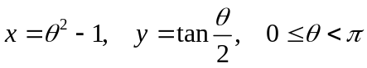.
Find the area of the region which is bounded by C, the y-axis and the x-axis for which 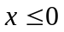. Give your answer to 4 decimal places. [4]

2 The position vectors of A and B with respect to the origin O are a and b respectively. The point C is such that OACB is a parallelogram. The point P on AC is such that AP : PC = 1: 2 and the point Q on BC is such that BQ : QC = 1: 2.

(i) Find 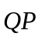 in terms of a and b. [2]

(ii) Show that 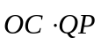can be written as 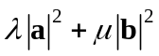, where 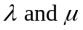are constants to be found. [2]

(iii) Given that 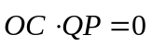, identify the shape of the parallelogram OACB, justifying your answer. [2]

3 (i) Given that the first three terms in the expansion of 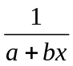 are 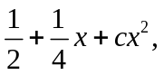find the
values of a, b and c. [3]

(ii) Use your answer in part (i) to find an approximation to the area of the region bounded
by the curve 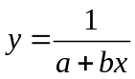, the two axes and the line 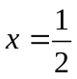. Give your answer in the
form 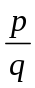 where p and q are integers. Hence find an estimate for ln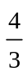. [3]

4 (i) Prove by induction that, for all positive integers n and for 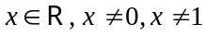,
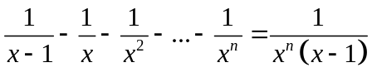. [4]
(ii) Find the range of values of x for which  exists given that
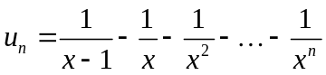. [3]

5 (i) A hospital patient is given a pill containing 50 units of antibiotic at 12pm. By 1pm, the number of units of antibiotic in the patient’s body has dropped by 12%. By 2pm, a further 12% of the antibiotic remaining in the blood at 1pm is lost. Given that the rate of decrease is such that the amount of antibiotic drops by 12% every one hour, find the amount of antibiotic remaining in the blood at 6pm. [2]
(ii) A doctor considers prescribing a course of treatment which involves the patient taking the pill every 6 hours over a long period of time. It is given that
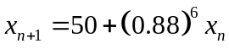,
where x_{n} denotes the number of units of antibiotic in the body after the n^{th} pill is taken.
(a) As , 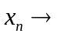. Determine the value of . [2]
(b) Show that 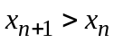 if 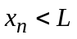;
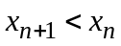 if 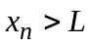 . [3]

6 The functions f and g are defined by
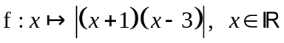,
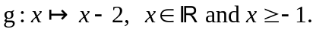

(i) Show that gf exists and state the range of gf. [3]

(ii) Show that f is not one-one. State the largest value of k for which f is one-one if the domain of f is restricted to 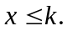 [2]

(iii) Using the domain found in part (ii), define 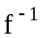 in a similar form. [3]

7 (a) (i) Use the standard series for 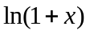 and 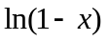 to find the first three non-zero terms in the series for 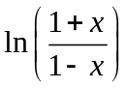. [2]
(ii) By choosing a suitable value for x in your answer for part (i), find 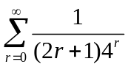.
[3]
(b) Given that 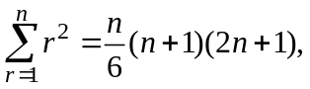 find, in terms of a,
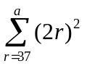, where a is an integer and a 37. [3]

8 (i) Sketch the curve with equation
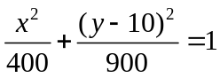.
[There is no need to indicate the x-intercepts on the curve.] [1]

(ii) The region lying in the first quadrant bounded by the curve, the x-axis, the y-axis and the line 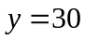 is rotated completely about the y-axis to form a fish bowl into which water flows. Given that units on the axes are centimetres and h cm 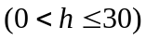 denotes the depth of water in the fish bowl, find, in terms of h, the volume of water in the bowl.
[4]

(iii) Water flows into the fish bowl at the constant rate of 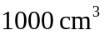 per minute. Find the rate at which the water level is increasing when the depth is 15 cm. [3]
State the value of h at which the rate of increase of the water level is the least.
[1]

9 (a) Sketch the graph of 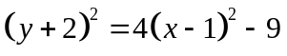, showing its main relevant features. [3]
Hence find the range of values of k such that there are no real roots to the equation
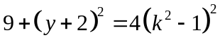. [2]

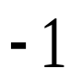
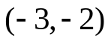
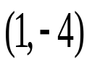
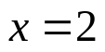

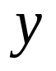
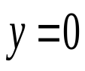
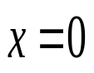

(b) The diagram below shows the graph of 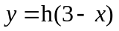. On separate diagrams, sketch the graphs of

(i) 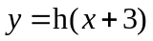, [2]
(ii) 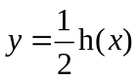. [3]

10 (a) (i) Using integration by parts, or otherwise, find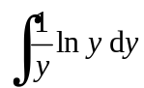. [3]
(ii) Given that 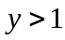 and 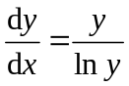, find y in terms of x. [3]

(b) (i) Show that 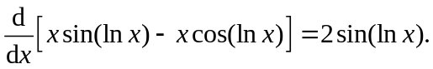 [2]
(ii) Find the exact value of 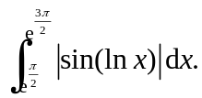 [3]

11 The plane 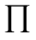 has equation 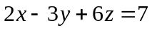 and the line l has equation 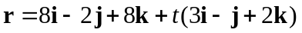.

The points A and B on l are given by 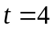and 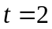respectively.
(i) Find the angle ABO. [2]
(ii) Find the coordinates of the foot of perpendicular from A to . [3]
(iii) Find the acute angle between and the plane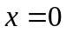. [2]
(iv) The point on l where 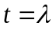is denoted by P. Find the set of values of for which the perpendicular distance from P to is less than 3. [4]

12 (a) Let z be the complex number 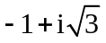. Find
(i) arg (z), [1]
(ii) the real number a such that 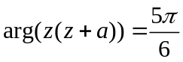. [4]

(b) Solve the equation 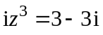, leaving your answers in the form 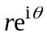, where r > 0 and 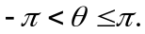 [5]
Deduce the roots of the equation 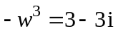 in a similar form. [3]

